# Description: Newsletter

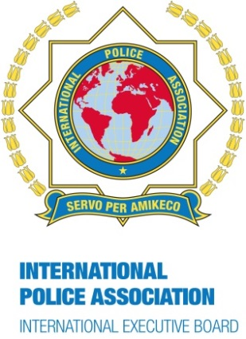**IPA Newsletter**

**December 2016**

International Administration Centre

Arthur Troop House

1 Fox Road, West Bridgford

Nottingham, NG2 6AJ

England

Tel: + 44 115 945 5985

Email: iac@ieb-ipa.org

Net: [www.ipa-iac.org](http://www.ipa-iac.org)

**Season’s Greetings!**



**We wish all IPA Newsletter readers a most wonderful time!**

**WORD OF INTRODUCTION**

I wish you all….

When you lose a friend, it is not uncommon for the mourning process to bring up a few simple questions. We want to rewrite a beautiful story, we would like to remember and go back to the roots, to the source …

When did we meet?

How did this friendship start?

And it so happens that sometimes we simply cannot recall the memory, that it has become a victim or beneficiary of time. This particular memory might have since given way to other memories, to the journey of this friendship, to what nourishes it and leads it to its culmination, before the separation.

To me, this proves that friendship is a feeling which is alive and feeds, which nurtures, experiences, forgets, forgives and rejoices. An endless sharing that creates a bond which is sometimes stronger, more persistent and more durable than love.

A little while ago someone who is very special to me told me: why do you deal with all these problems that occur within the IPA? Leave those people to sort out their fights by themselves, and focus on what the IPA is really about: a burst of friendship, an abundance of good times to share, to laugh, to celebrate life. Those who fight, those who look for gossip have no place in the IPA.

Soon the holiday season is upon us. I would like to take this opportunity to offer all of you my best wishes for friendship. Maybe I do not remember how or where we met, but I would like our friendship to continue and grow, that it will not become the victim of anything, but will always be beneficial to us.

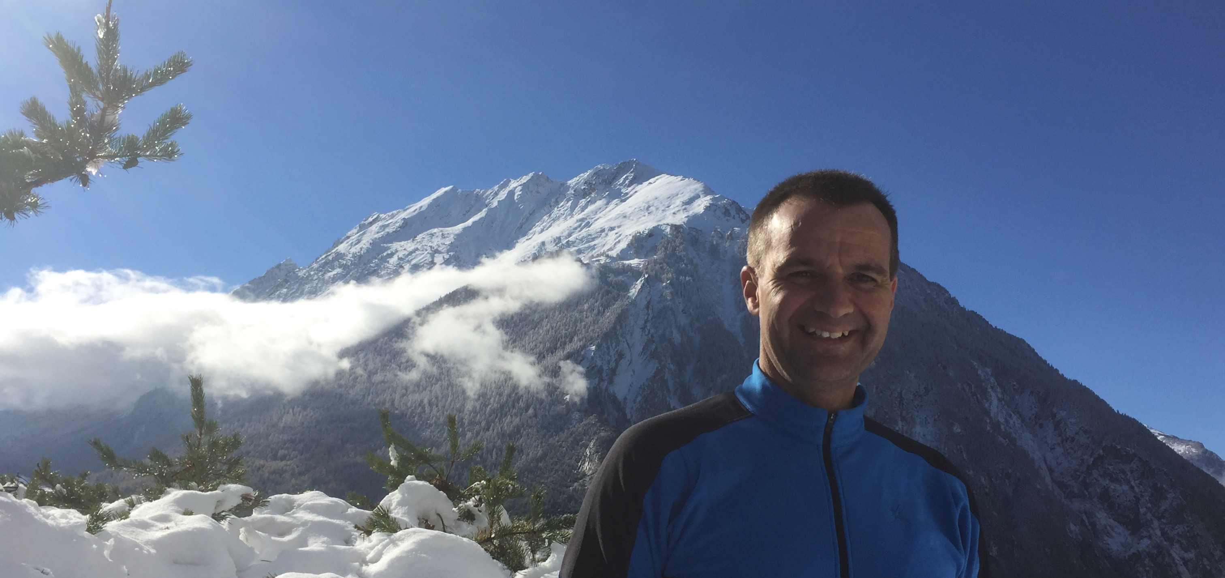

It is with all my friendship that I want to serve the IPA.

I wish you a Happy New Year and Merry Christmas to those of you who celebrate it.

***Pierre-Martin Moulin, IPA President***

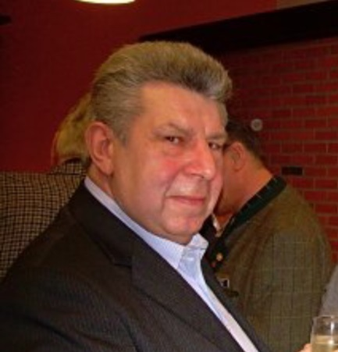

OBITUARY

SERGE KLINGELS

Chers amis,

En date du 13 novembre 2016 Serge Klingels nous a quittés.

J’avais le privilège de représenter l’IEB aux funérailles de notre ami Serge et je remercie la famille de m’avoir donné la possibilité de prendre la parole lors du service religieux.

Au nom de la communauté internationale de l’International Police Association nous exprimons à toute la famille en deuil, et à la section Belge nos condoléances les plus sincères.

Il y a à peine 3 mois, j’ai rencontré notre ami Serge pour la dernière fois à Luxembourg. Serge était plein d’énergie et plein d’idées. Personnellement j’ai perdu un compagnon fidèle.

Serge était une personnalité droite et avait de belles qualités humaines. Serge savait faire valoir son point de vue et défendre ses idées avec conviction et fermeté. Mais c’était un homme bon et qui n’était pas rancunier. Il était un chevalier de notre devise « Servir par l’amitié »

Serge, tu n’avais plus la possibilité de nous dire au revoir. Nous te remercions tous pour ce que tu as fait pour notre association.

Adieu mon ami.

C’était un honneur de t’avoir connu et de pouvoir te compter parmi nos amis.

Repose en paix.

***Romain Miny, Treasurer Finances***

**AROUND THE WORLD**

IPA France’s brand-new World Champion in Boxing:

Maïva Hamadouche

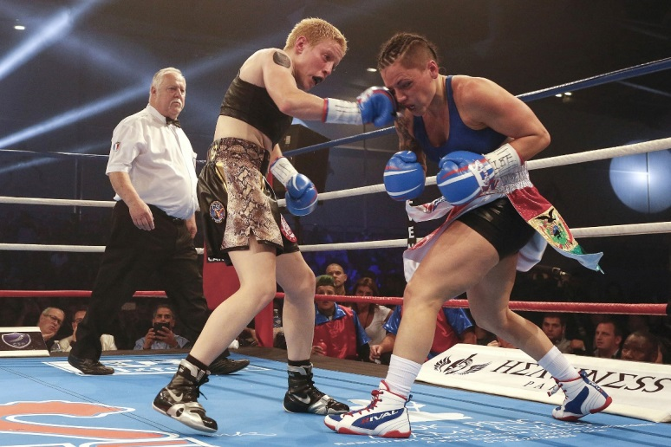On 10 November 2016, IPA France member and national French boxing champion Maïva Hamadouche, was crowned IBF World Champion in the super featherweight category, after an exceptionally intense 10-round fight against the American champion Jennifer Salinas. The tension had already been palpable the day before during the weigh-in, and the fight turned out as expected: rough and pitiless.

Maïva’s victory was final and conclusive: 97/93; 97/93; 98/92.

Her American opponent had previously experienced 23 professional fights with 130 rounds, resulting in 19 victories, and 22% knockouts. Maïva, on the other hand, has only been a professional boxer since 2013. Her ascent in the boxing world, however, has been explosive: French national champion in 2014, double EBU European champion in 2015, Vice World Champion in 2016, after winning the professional WBC silver belt in the lightweight category. 14 fights and 70 rounds have resulted in an amazing 73 knockouts.

She was defeated only once in October 2015 by the WBC World Champion Delfine Persoon, a Belgium boxer. Paradoxically, it is this brave defeat which was to enable her to be truly appreciated on an international level. Very respectful, at the end of a difficult fight, Persoon introduced her young opponent as the next WBC World Champion.

Maïva is a full-time police officer working in the CSI (Compagnie de Sécurisation et d’Intervention) in Paris, which specialises in the intervention of urban violence and the fight against delinquency. This special unit played an important part during the devastating terrorist attacks which occurred in Paris in 2015. Despite working full-time, Maïva trains several hours each day. She is, however, granted special leave when preparing for important fights.

Maïva is a police officer not only in her job, but also in the ring, and is proudly displaying a non-permanent tattoo on her right shoulder, depicting the badge of her unit. She has been a member of the IPA since 2014.

You can congratulate Maïva on her Facebook page:

<https://www.facebook.com/maiva.hamadouche>

***Jean Marc Riss, IPA France***

IPA World Prize 2016

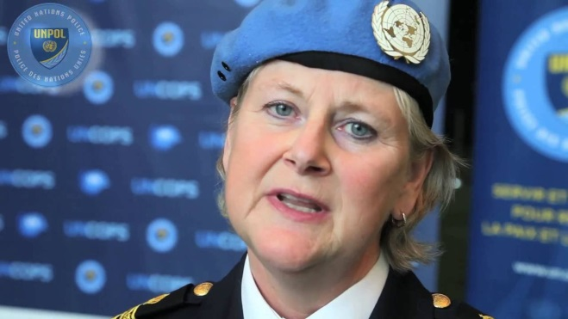IPA Sweden is honoured to confirm that one of this year’s recipients of the IPA World Police Prize is IPA Sweden member Maria Appelblom, who was awarded by the International Executive Board of the IPA.

Since its introduction, the IPA World Prize (formerly known as the IPA World Police Prize) has only been awarded 7 times:

|  |  |
| --- | --- |
| 1994 | Interpol |
| 1995 | The founder of the IPA: Arthur Troop |
| 1998 | IBZ Gimborn |
| 2000 | The United Nations Office of Drug Control and Crime Prevention |
| 2003 | Concerns of Police Survivors (COPS) |
| 2006 | Dr. Francisco Vicente Badenes (Brazil) |
| 2011 | Ahuva Tomer, Lior Boker and Yitchak Melina (Israel) |

Ms Appelblom has been a member of the Swedish Section of the IPA since 1996, and is a former member of the Regional IPA Board of Region 6, Sweden. Ms Appelblom is at present the Chief of the UN Standing Capacity.

She was nominated by the Swedish Section for her unselfish work on Human Rights, equal opportunities as well as for her dedication to making this world a better place. Ms Appelblom is one of the founders of ‘Woman to Woman’ (Kvinna till Kvinna). This NGO supports women in war zones with supplies of female necessities. She participated actively in the formation of the Nordic Baltic Woman Police Association, of which she remains an active member.

Her inexhaustible voluntary work for other human beings over the years in many countries around the world and her dedication in her daily work mirror Ms Appelblom’s genuine concern for fellow human beings, and her belief in making a change ensures that she is a worthy winner of the IPA World Prize.

This year, the IPA World Prize was awarded to 2 recipients. The second award goes to the IPA Greece regions of Kilkis, Drama, Magnesia, Akarnania, Lesvos and Chios for their members’ unselfish efforts in providing humanitarian support and services to arriving refugees.

Both IPA World Prizes were presented at the Award Winner’s Evening during the recent IPA World Congress in Auckland, New Zealand, and the award for Maria Appelblom was taken home to Sweden by the Swedish Section, as Ms Appelblom was not able to participate due to other commitments on an international level.

On behalf of the Swedish IPA section, I would like to forward my most sincere congratulations to Ms Maria Appelblom.

***May-Britt Rinaldo, President IPA Sweden***

33rd Annual Congress of IPA Cyprus

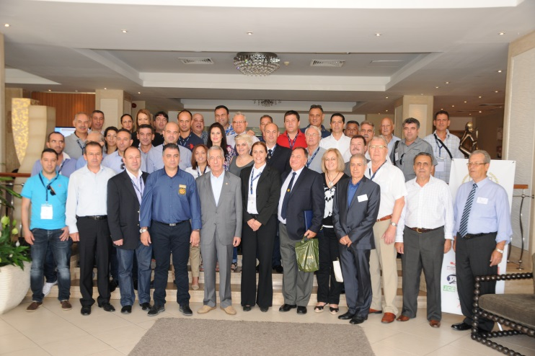The 33rd Annual Congress of Section Cyprus was hosted this year by the region of Limassol, between 27-30 October 2016.

The congress was attended by delegations from Greece, Israel, Moldova and Romania.

*Delegates of IPA Cyprus*

*together with the visiting foreign delegations*

In addition, the National Executive Council of the Section and the members of the National Council took part. IPA Vice President Gal Sharon was our special guest at the congress and addressed the delegations from IPA Cyprus as well as the guests who were present.

Besides the work of the congress, the programme included guided sightseeing tours, visits to archeological and historical places and our guests were able to get a taste of the culture of our country as well as the friendliness and hospitality of the Cypriot people. They were also given the opportunity to discover some of the beautiful sights of Cyprus: the countryside, the Troodos Mountain and the famous Kykkos Monastery.

The congress participants were briefed about IPA’s work and other IPA activities which were carried out by the Section and the IPA regions during the year under review. The heads of the foreign delegations addressed the congress participants and expressed their thanks for the invitation.

The President of Section Cyprus briefed all participants about the IPA work achieved during the year, and they approved the decisions taken by the National Executive Council. Future plans and projects were discussed and decisions approved.

On Saturday night, the region had organised a farewell dinner which was attended by more than 200 people, including the police and local authorities, the congress attendees, the foreign delegations, prominent people, a large number of IPA members and others.

Both the congress and the celebrations were fruitful and successful. I take this opportunity to thank the chairman of the Region, Kyriakos Perikleous, and the National Board for everything they did to make the 33rd Annual Congress a success.

In conclusion I assure the IEB and all national sections that we will continue offering our services to the IPA and all members worldwide.

Servo per Amikeco

***Michael Odysseos, President IPA Cyprus***

Remember the Alamo!

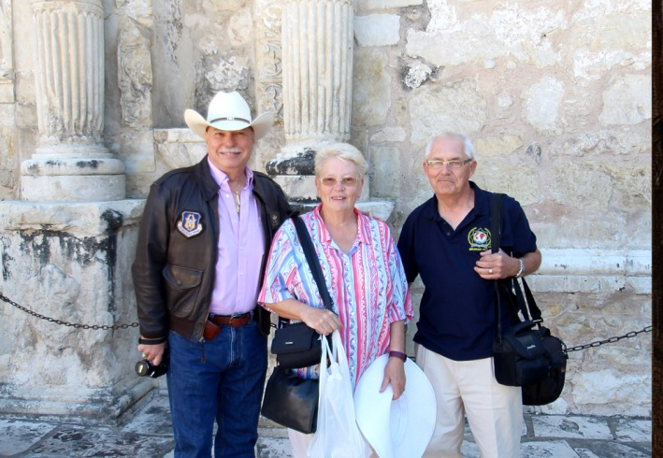In October 2016 my wife Kathy and I set off for a special retirement holiday, visiting parts of Louisiana and Texas to follow our interests in American history, Cajun food and country music. The trip had been a year in planning, and at an early stage we completed the IPA travel form to seek advice.

*Ed, Kathy and Graham at the Alamo*

After an initial contact, we were contacted by Louis Gaydosh, a lieutenant in the New Orleans Police Department, and Ed Kassof, a retired NYPD officer and current president of the San Antonio region. Both provided useful information and advice that helped us with our plans. We decided to fly to Dallas Fort Worth and after a few days there drive to Louisiana staying for nearly 2 weeks across the lake from New Orleans at 2 different locations, Abita Springs and Lafayette. Then we were to drive to Texas with stays at San Antonio and Austin. Finally we would drive back to Dallas for our flight home. Stopping in Dallas a few days before our long drive was a good decision given that our main luggage did not make the connection at Heathrow, and we had to wait 2 days for it to arrive…

We had a very enjoyable time in Louisiana thanks to a lot of information given by Louis Gaydosh on various sites and attractions in the North Lakeshore area. In particular, considering our interest in history, Louis arranged for us to contact a friend of his, Katrina, who is a professional guide in New Orleans. With her we arranged a personal guided tour of the French Quarter and were given a lot of information and insight into the history of New Orleans. While in Louisiana, we also took in a swamp tour, a brewery trip and the 3-day Cajun food and music festival at Lafayette.

In San Antonio we stayed in the Menger hotel, recommended by Ed Kassof. It was a superb choice as it is a hotel with lots of history and special rates for IPA members. It also met our particular interests as it was built only 25 years after the famous Alamo battle and is opposite what is left of the old mission. Ed met us on our 2nd day in San Antonio and took us for a tour of the Alamo. For lunch, we shared a Mufaletta sandwich, a gigantic sandwich cut into 12 sections. Even the sandwiches in Texas are big! Afterwards Ed gave us a tour of the Riverside Walk area, including a boat trip. Ed’s knowledge of the history of Texas and the Alamo in particular was fantastic.

In Austin our accommodation was only 10 minutes’ walk from the Department of Public Safety, which now incorporates the Texas Rangers. Louis Gaydosh had mentioned the DPS had their own museum. On presenting the IPA membership card, the officer on duty was very welcoming and allowed us to visit the museum. Despite being quite small, the museum includes a lot of exhibits and gives a good account of the history of the DPS and the Texas Rangers.

On the drive back to Dallas we called at the Texas Rangers Hall of Fame and Museum at Waco. It is dedicated to the history of the Texas Rangers and also has a large section devoted to particular Texas Rangers who have given service above and beyond the call of duty.

We thoroughly enjoyed our visit to Louisiana and Texas. Our thanks go to Louis Gaydosh, Ed Kassof and Bud Lathrop for all the help they gave to make it more enjoyable and memorable.

***Graham Hey, IPA UK member***

**ON THE TABLE OF THE IEB**

Awardees of the Arthur Troop Scholarship 2017

Congratulations to the awardees of the 2017 Arthur Troop Scholarship:

Awardee: Section:

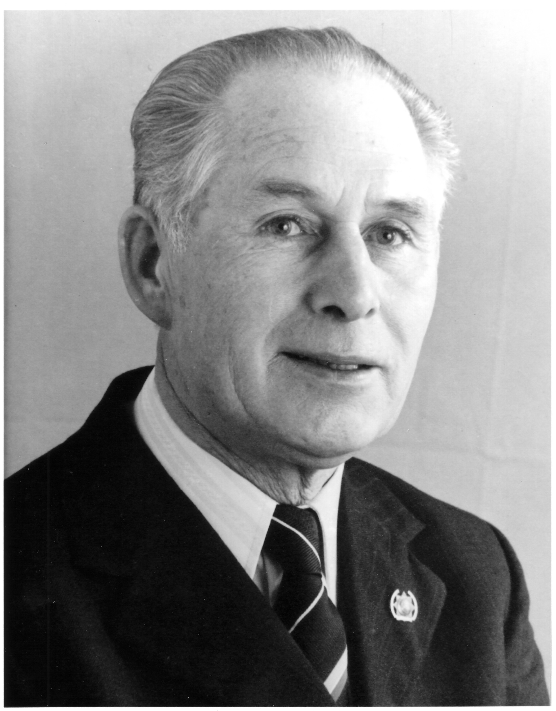Nicole Warner Australia

Rebecca Boyd Canada

Chi Chung Lau Hong Kong

Ieva Janaviciute Lithuania

Hamish Keer-Keer New Zealand

Robinson Wilder Leiva Bancayan Peru

Claude Malan South Africa

Janaka B Hapuhinna Sri Lanka

Mark Lewis UK

Thomas Stanzoni USA

During the World Conference in Auckland, New Zealand, I announced the ten awardees of the ATS 2017. In total, 33 applications had been forwarded for assessment. The awardees will receive between 1,000 and 2,500 Euros for their upcoming participation in a seminar at IBZ Gimborn in 2017.

The Arthur Troop Scholarship (ATS) Procedures, Application Form and Assessment are under review and will be presented at the World Congress 2017.

The ATS 2018 will, however, follow the current procedures, and terms of application will be announced in February 2017 in the IPA Newsletter.

Please feel free to forward enquiries and questions regarding the Arthur Troop Scholarship to the following email: [cpc@ieb-ipa.org](mailto:cpc@ieb-ipa.org)

***May-Britt Rinaldo, Chairperson of the Professional Commission***

**IPA HOUSES – YOURS TO DISCOVER!**

C:\Program Files (x86)\Microsoft Office\MEDIA\CAGCAT10\j0157763.wmf***If you would like to visit Paris, IPA France offers two facilities within easy reach of the French capital.***

Our IPA House ‘Pierre Barbaud’ is situated in Villemomble, a mere 15 km away, and the IPA Guestroom on offer is equally only located 14 km away from the centre of Paris.

Apart from everything that Paris has to offer, both facilities are also close to Versailles, Fontainebleau and Disneyland.

IPA House ‘Pierre Barbaud’ in Villemomble, Paris

The accommodation can be found on two levels: the 1st floor has an apartment housing a maximum of 4 people, and contains a fitted kitchen for 6, a bathroom (shower & washbasin), separate toilets, one bedroom with a double bed, and one bedroom with two single beds.

The studio on the ground floor has 2 single beds, a fitted kitchen, a bathroom (shower & washbasin) and toilets.

The nearest railway station, Le Raincy-Villemomble, is only 5 minutes away and offers excellent connections.

**Contact Details & Bookings:**

* Manager: Céline
* Address: 44 Avenue Gallieni, 93250 Villemomble
* Mobile: ++ 33 6 10 38 24 78
* Email: [ipahouse.france@ipafrance.org](mailto:ipahouse.france@ipafrance.org)
* Website: <http://ipafrance.org>
* Enquiries: Please contact Céline for rates and bookings.

IPA Guestroom, Neuilly-Plaisance, Paris

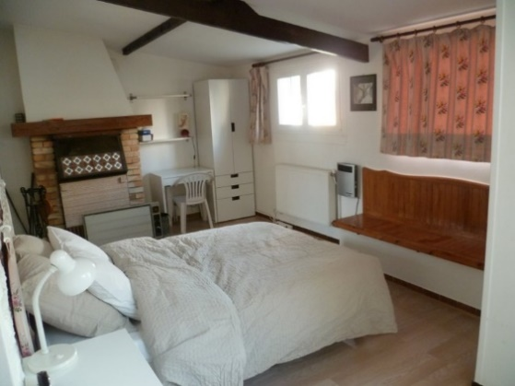This lovely facility offers one room sleeping 2 people, and comprises a Queen size bed, a separate bathroom, toilets and shower.

The accommodation benefits from private access, WiFi, as well as a refrigerator and kettle.

Bedlinen and towels are provided.

The closest train station (Neuilly-Plaisance) is 3 minutes’ walk away.

Disneyland Paris (30 km), can be reached either by train (RER line ‘A’, Marne-la-Vallée-Chessy), or by car taking the motorway A4.

**Contact Details & Bookings:**

* Manager: Rika Condaminas
* Address: 18 bis rue Gambetta, 93360 Neuilly-Plaisance, France
* Tel: ++33 9 5384 8610
* Email: [ipa.fr.guestroom@gmail.com](mailto:ipa.fr.guestroom@gmail.com)
* Website: <http://ipafrance.org>
* Enquiries: Please contact Rika for rates and bookings.

***Rose Lourme, President IPA France***

**LAST WORD**

For many IPA members, being part of the association means first and foremost getting together at an event or travelling, meeting up with old friends as well as starting new friendships.

We at the IAC try and keep everyone informed as much as possible about all the opportunities out there for you.

For us to do so in the best way, we need all sections’ support.

So please keep us informed about the events in your sections – which we are then happy to send around the IPA world for you.

The more you send us, the more we can offer all of you ☺

*Elke*

**CALENDAR OF EVENTS**

Please find below a list of IPA events for the next 12 months:

|  |  |  |
| --- | --- | --- |
| ***Section*** | ***Date*** | ***Event*** |
| Austria | 28 Jan-4 Feb 2017 | Ski Week Nassfeld-Hermagor |
| Germany | 22-28 Feb 2017 | 50th Carnival of IPA Cologne |
| Finland | 28 Feb-4 Mar 2017 | IEB Meeting, Äkäslompolo |
| Austria | 20-23 Apr 2017 | XIX National Congress, Pörtschach |
| Croatia | 29 Apr-13 May 2017 | IPA Dubrovnik Friendship Weeks 2017 |
| Spain | 12-21 May 2017 | Barcelona Supermotor Event |
| Canada | 21-28 May 2017 | Cruise to Bermuda |
| Germany | 23-27 May 2017 | IEB Meeting, Gimborn |
| Spain | 28 May-3 Jun 2017 | Barcelona Golf and Leisure Week |
| USA | 11-16 Jun 2017 | Young Police Officers’ Seminar, Green Bay |
| USA | 19-28 Jun 2017 | Pacific Northwest Tour |
| Estonia | 14-16 Jul 2017 | IPA Estonian Summer Days |
| South Africa | 29 Jul-13 Aug 2017 | International Youth Gathering |
| Germany | 11-13 Aug 2017 | 1st Int. Motorcycle Gathering, Hamburg |
| Bulgaria | 19-24 Sep 2017 | 62nd IPA World Congress, Albena |

**FORTHCOMING GIMBORN SEMINARS**

Please see below a 4-month summary of seminars with vacancies, offered by our international education centre IBZ Gimborn in Germany.

If you are interested in taking part in any of these seminars, please follow the link:

[www.ibz-gimborn.de](http://www.ibz-gimborn.de)

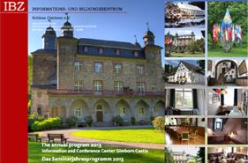

|  |  |  |
| --- | --- | --- |
| ***Date*** | ***Seminar*** | ***Language*** |
| 05-09 Dec 2016 | Drogen – Jedem seinen Rausch? | G |
| 23-27 Jan 2017 | Interkulturell kompetent in der Zuwanderungsgesellschaft | G |
| 23-27 Jan 2017 | Interkulturell kompetent in der Zuwanderungsgesellschaft | G |
| 30 Jan-03 Feb 2017 | Flucht, Migration und Asyl – Deutschland nach der Flüchtlingskrise | G |
| 06-10 Feb 2017 | Rocker- und Motorradbanden – Gesichter organisierter Kriminalität | G |
| 13-17 Feb 2017 | Gewalt im Spiel – Ultras und Hooligans im Umfeld von Fußballspielen | G |
| 06-12 Mar 2017 | Fasten? Trau Dich!  Heilfasten im Oberbergischen Land | G |
| 06-10 Mar 2017 | Ethik unter Druck – Werteorientiertes Handeln auf dem Prüfstein | G |
| 13-15 Mar 2017 | Zeitalter der Populisten | G |
| 27-29 Mar 2017 | Die Macht der Bilder oder Bilder an die Macht | G |