# Description: Newsletter

**IPA Newsletter**

**March 2017**

International Administration Centre

Arthur Troop House

1 Fox Road, West Bridgford

Nottingham, NG2 6AJ

England

Tel: + 44 115 945 5985

Email: iac@ieb-ipa.org

Net: [www.ipa-iac.org](http://www.ipa-iac.org)

**IPA and IBZ Gimborn in perfect harmony ☺**

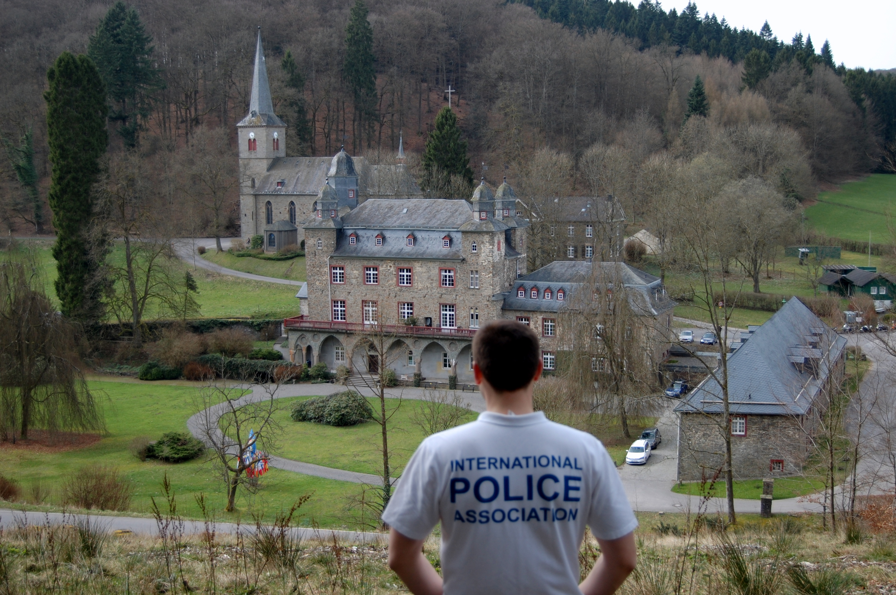

**Photo supplied by Rimvydas Eidietis, Arthur Troop Scholar 2016**

**WORD OF INTRODUCTION**

**Time for Innovation**

‘No innovation, no future’ was the theme of a conference I attended recently.

What a statement for an association like ours!

I am 47 and I already think I have been ‘sticking’ around for too long, that it is time to open the door to the young generation, to trust them and let them lead our IPA towards a promising future.

I know this will not please some of you, but once again, think about it:

Arthur Troop was 36 when the IPA was officially launched! I already mentioned this in one of my previous introductions.

I was pleased to read recently that several IPA sections had circulated a message, encouraging young police officers to join the next IPA World Congress, in order to participate and hold a meeting to gather best practice and ideas on how to develop and attract younger members. I am convinced that there is nothing worse than when people hold on to positions for too long and don’t give a chance to the future generation, for innovation to become a central principle in the IPA.

It is always nice to recall the memories of the past, but let us recognise that the future is not in our hands. Let’s give a chance for a new sunrise, for new dreams to become reality, and let us encourage those who wish and desire to do this.

If we don’t, we will miss the target. The IPA is a living association and needs a permanent adjustment to today’s fast-paced world. What used to take 20 years to change only takes a short time today. Trust the young ones, invite them to participate, to be involved. Listen to them, breathe the fresh air they offer and don’t close the door. Lay back, smile and laugh while the next generation takes over and ensures our future….

I believe that this is the way to go. So dear young colleagues, show up, get involved and share your visions and ideas. We need you. The future does not lie in our past, but in your dreams! Come numerous to our next IPA World Congress and be loud, so that we will hear you!

Servo per Amikeco

***Pierre-Martin Moulin, IPA President***

**AROUND THE WORLD**

African Chapter meets in South Africa



***The African Chapter of the International Police Association (previously known as the African Task Team) met in Pretoria, South Africa from 9 to 12 February 2017.***

The Meeting was attended by all 6 active IPA Sections of Africa with each represented by the following delegates:

|  |  |  |
| --- | --- | --- |
| * Botswana: | -Ms Neo Bodilenyane  -Mr Emmanuel Morris | -Secretary (co-opted)  -NEC member (co-opted) |
| * Kenya: | -Mr Jared Ojuok  -Mr Kibet Wilhelm | -Secretary General  -IPA member |
| * Lesotho: | -Ms Momosa Hlao  -Mr Thato Mokoteli | -2nd Vice Pres. – Admin.  -Secretary General |
| * Mauritius: | -Mr Outam Kumar Guness  -Mr Gaètan Marie Papillon | -President  -Social and Cult. Comm. |
| * South Africa: | -Mr H Vos (Vossie)  -Ms Tessa Deyzel | -AC Chairperson and President  -AC Secretary and Sec. Gen. |
| * Swaziland: | -Mr William Dlamini  -Ms Doreen Tsabedze | -1st Vice President (Dep Comm.)  -Secretary General |

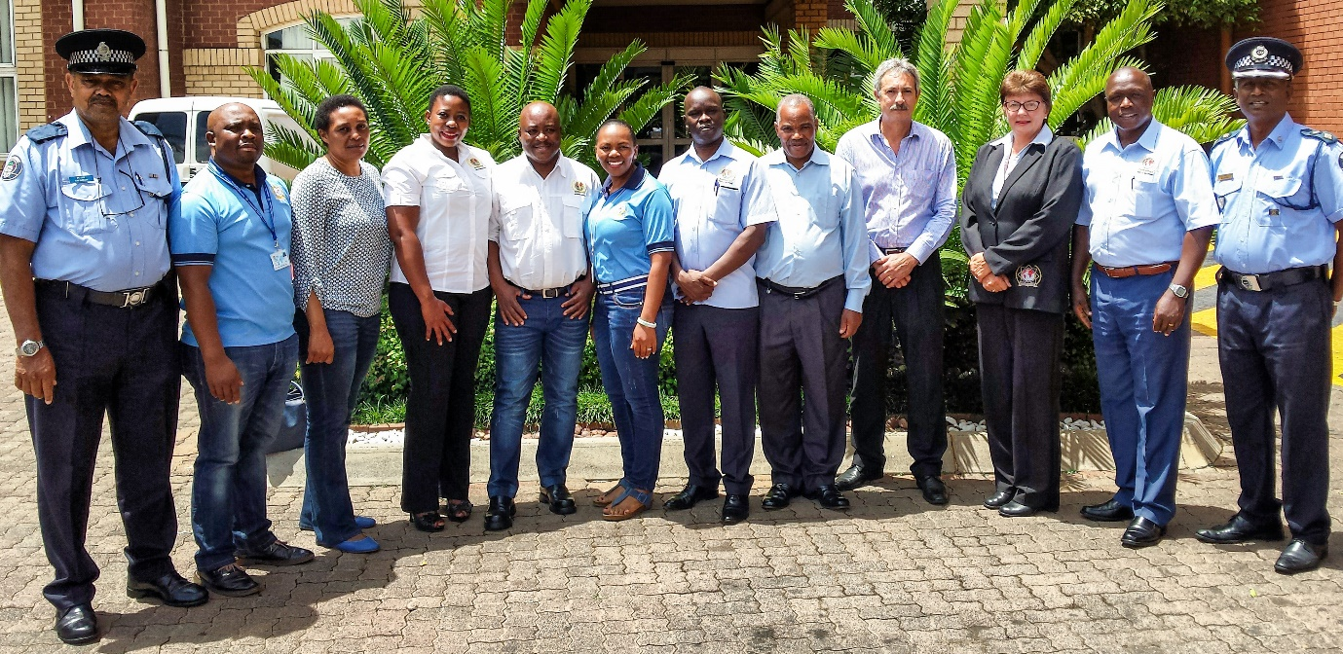

*Gaètan Papillon, Thato Makoteli, Doreen Tsabedze, Neo Bodilenyane, Emmanuel Morris, Momosa Hlao, Jared Ojuok, William Dlamini, Vossie Vos, Tessa Deyzel, Kibet Wilhelm, Outam Kumar Guness*

The mandate of the African Chapter is found in the initial Memorandum of the International Secretary General dated 6 June 2012 and entails the following:

* Responsible for promoting and recruitment of other African Countries into the IPA
* Monitor activities in the various Sections with the intention to promote visibility
* Assist other IPA Sections within Africa to promote projects such as the Police Exchange Programmes and National Youth Seminars
* Assist with the re-activation of inactive and suspended Sections

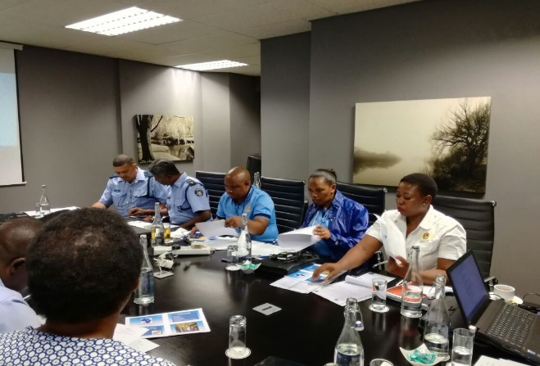Discussions during the proceedings were open, frank and transparent with a critical emphasis upon the African Chapter being a conduit in Africa for the promotion of IPA activities across all Sections, but acknowledging that committee decisions will merely be recommendations to Sections and not instructions.

Following in-depth discussions during the meeting, the delegates agreed that in alignment with the original mandate the African Chapter will act collectively to:

* Assist and guide Sections in the discharge of its duties relating to the aims and objectives of the IPA across Africa,
* Guide and advise Sections pertaining to the continuous review of national IPA constitutions (statutes), rules and other relevant governance principles in order to ensure that they are appropriately aligned to international amendments, the respective national legislation and/or other relevant requirements,
* Launch projects directed at marketing the IPA in non-IPA countries in Africa - the aim is to grow IPA in Africa,
* Develop a holistic marketing strategy for African Sections,
* Improve communication and cultural relations through various initiatives,
* Establish sub-committees for specific events/projects,
* Develop strategies for fundraising for Chapter activities.

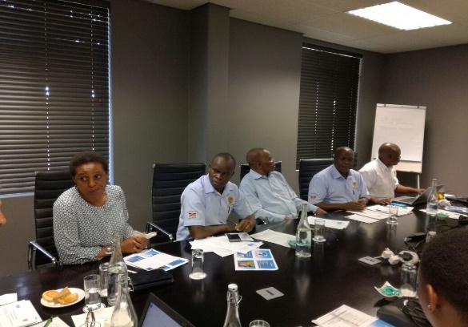With only six active Sections in Africa, everybody was in agreement that there are great opportunities to grow the Association on the continent – not only within the active Sections, but across all other countries in Africa.

Various initiatives are following and further analysis will be undertaken to promote the IPA in countries where the IPA is still unknown, as well as in those countries where IPA Sections have become dormant.

Funding of such initiatives does, however, remain the most critical dependency for the Chapter in fulfilling its obligation. Sections in Africa do not have the required funding to undertake cross-border initiatives to trigger IPA awareness and re-activation of dormant IPA Sections.

All Sections represented held a strong opinion that as a collective, it will not shy away from the challenges, and that it will do its utmost as a collective to make the IPA light shine across Africa.

The gathering of the various Sections did, however, once again prove that within IPA there are no boundaries regarding race, gender, culture, religion, etc. It was wonderful to experience once more the true spirit of friendship that exists amongst the IPA – irrespective of who we are and where we are from.

The association amongst the delegates was an experience that was second to none – it was truly a few days of work and socialisation that we will all foster forever.

Africa is undoubtedly unique, but within the ranks of the IPA we all share the same IPA motto, aims and objectives.

Friends we are and friends we shall remain for ever.

***Servo per Amikeco – Friendly African Greetings to All!***

***Vossie Vos, Chairperson African Chapter***

29. Skiwoche der IPA Österreich

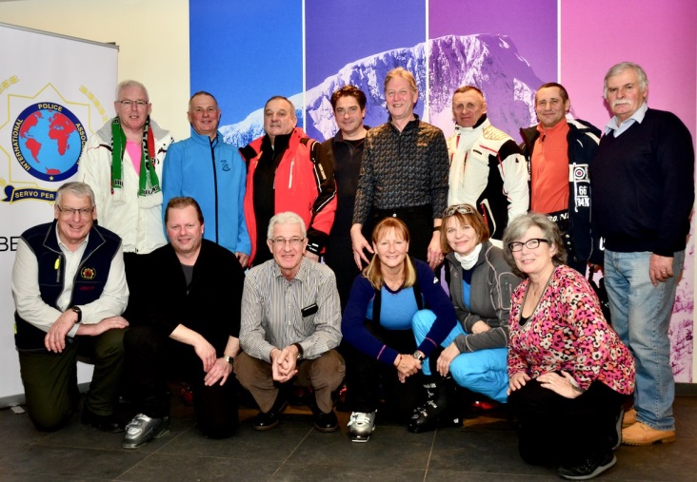Exekutivbeamte/innen aus 10 Nationen (Deutschland, Italien, Irland, Kanada, Norwegen, Schweden, Schweiz, Slowenien, Russland und Österreich) haben sich Ende Jänner 2017 zur IPA Wintersportwoche in der Region Nassfeld-Pressegger See getroffen, um das Skifahren in der sehr schönen Region zu genießen.

Die Skiwoche wird seit 29 Jahren von der IPA Kärnten/Oberkärnten organsiert und bietet einen unvergesslichen Winterurlaub bei Freunden in Kärnten.

Neue Kontakte wurden auch bei dieser Skiwoche geknüpft und Freundschaften aufgebaut und gefestigt.

Die Skifahrer wedelten flott über die ausgezeichneten Skipisten und setzten schwungvolle Spuren in den Schnee. Die Betreuung der Wintersportler wurde von IPA Mitgliedern aus der Region übernommen. Der Bürgermeister der Stadtgemeinde Hermagor Pressegger See Siegfried Ronacher zeigte als ausgebildeter Skilehrer den Gästen das Skigebiet.

Für ausgezeichnete Stimmung sorgte am Dienstag beim offiziellen Unterhaltungs-abend im Landhof „Zum Waidegger Wirt“ der bekannte Musiker Robert Lexer. Für die langjährige Teilnahme und Treue wurden Rüdiger Schaiba (10 Jahre), Martina Schandl (20 Jahre) und Marlene Richter (25 Jahre) geehrt.

Die Quartiergeber und die IPA Oberkärnten überreichten Präsente als Dankeschön für die Teilnahme an den Skiwochen.

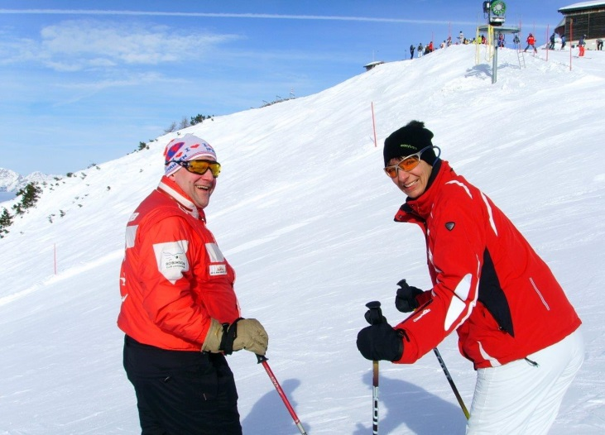Gemeinsames Skifahren und gesellige Zusammenkünfte mit kulinarischen Schmankerln aus der Region wie Spanferkel, Gulaschsuppe und Kaiserschmarrn bereicherten den Urlaubsaufenthalt in der Skiregion. Die italienischen Lokale mit ihren Nudel-, Fisch- und Muschelspezialitäten waren auch Stationen zur Mittagszeit. Gestärkt von dem vorzüglichen Speisenangebot wurden die Skiabfahrten in Angriff genommen.

Dienstags eine Fackelwanderung und ein gemütlicher Abend, und Donnerstags in der Apres - Ski Bar „Zum Alois“ mit einer Perchtengruppe als Überraschung standen auf dem Wochenprogramm.

Das Organisationsteam freut sich über eine unfallfreie Skiwoche und bedankt sich bei den Teilnehmern, Betreuern und Quartiergebern Landhof Zum Wirt, Hansbauerhof, Hotel Gartnerkofel und dem Alpen-Adria Hotel.

Allen ein herzliches Dankschön die zum guten Gelingen des Winterurlaubes für die IPA-Freunde beigetragen haben.

Die Vorbereitungsarbeiten für die 30. Jubiläumsskiwoche in der Zeit vom

27. Jänner bis 03. Februar2018 wurden bereits in Angriff genommen.

SERVO PER AMIKECO

***Ewald Grollitsch, IPA Österreich***

IPA Friendship Weekend in Scotland

The Tayside IPA Branch in Scotland ran a Friendship Weekend in Kingussie in the Cairngorms. 68 IPA members from the four home nations of the UK, plus Ireland, Germany and Sweden joined together for a memorable get together and a ‘Ceilidh’.

The IPA Whisky Forum met in parallel with the Friendship Weekend and there were outings to the Speyside Distillery as well as whisky and wine tastings in the hotel.

The Scotland-Ireland rugby match was watched with partisan interest on the Saturday afternoon, with cheering and silence, alternately from the opposing supporters depending on the scores. Henry and Ursula Mayer from Germany seemed rather bemused by the action on the rugby field.

A few of the many memorable moments of our IPA Friendship Weekend in Scotland can be seen in the following selection of photos:

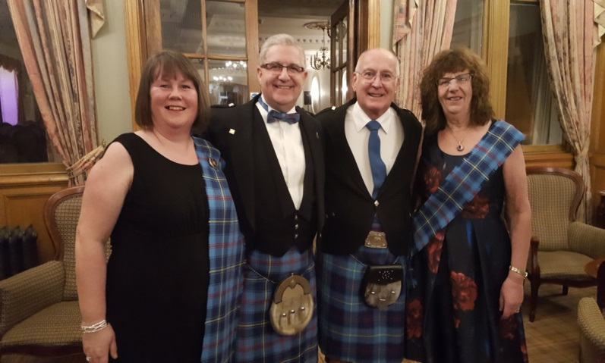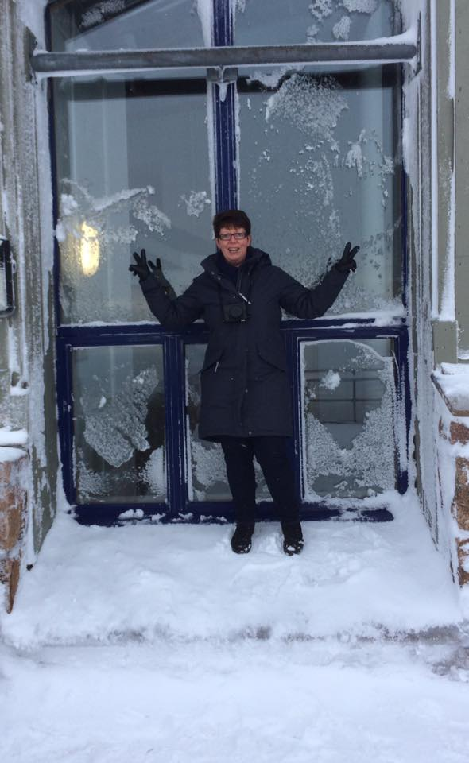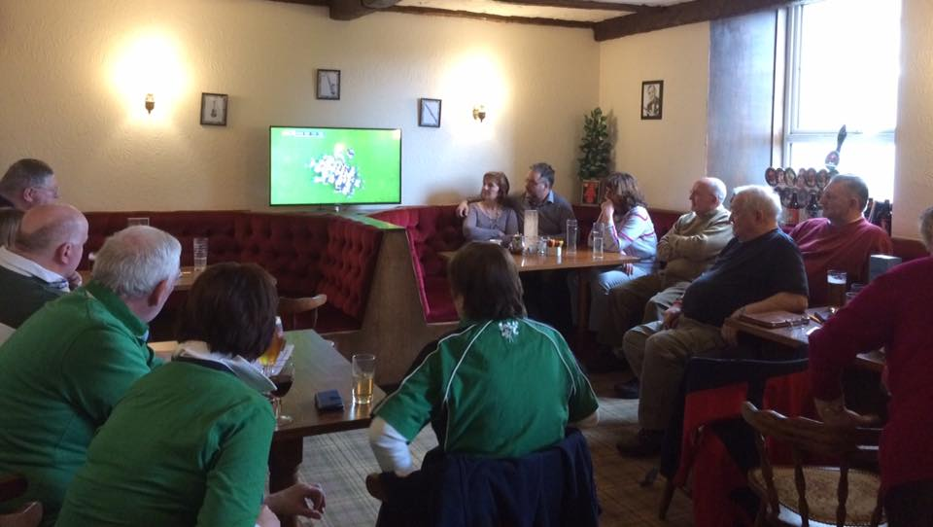

In the evening guests gathered for the ‘piping in’ of the Haggis to the dining room, followed by Scottish music and dancing.

On Sunday, the participants also took the opportunity to visit the Highland Wildlife Park with its polar bears, tigers and red pandas and the snow covered top of Cairngorm (the blue mountain) via a funicular railway.

A total of £1370 was raised for the Scottish Charity Air Ambulance during the Friendship Weekend. My thanks go to UK Vice President Yvonne McGregor and her husband David for organising a superb event in the true spirit of the IPA.

***Stephen Crockard, Head of Administration and member of IPA UK***

IPA South Africa’s West Coast Region supports Fitness Day

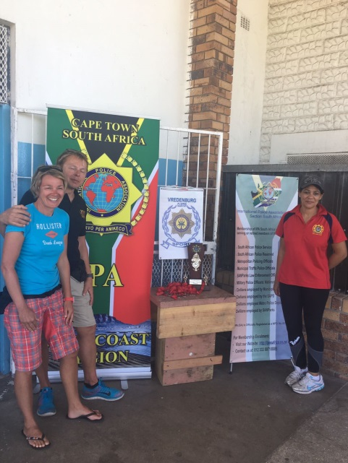On the 8th of February members of the South African Police Service in the Vredenburg Cluster launched the new Fitness Policy of the SAPS.

The day started with a 5km walk and mass aerobics. The rest of the day was filled with various sports activities and finally a potjiekos competition.

The IPA of the West Coast Region is proud to support the SAPS. The IPA provided a trophy and medals and also some prizes for this event.

We were also very fortunate to have two German Police officers, Frank Stephani and Krissi joining us for the day. They participated in several of the events and took the time to chat to some of our police officers.

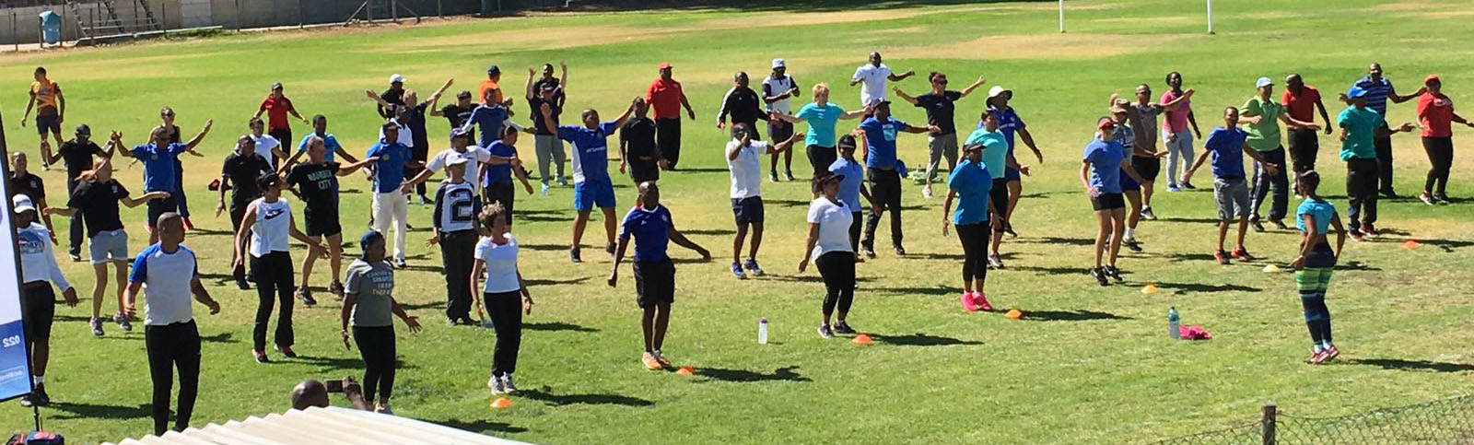A big thank you to Melvin C. de Bruyn for his hard work in organizing this event. Also thank you to the Community Police Forum of Laaiplek and **7 Stars** who helped to make this day a success.

We look forward to the next event!

Service through Friendship

***Elbie Gore, IPA South Africa National Editor***

**ON THE TABLE OF THE IEB**

Review of Arthur Troop Scholarship

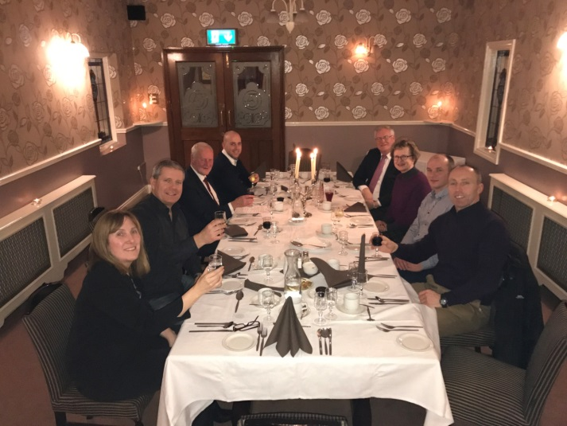One of the objectives for the present term for the Chair of the Professional Commission and the IEB is to update the Procedure for the Arthur Troop Scholarship and to improve the application form and assessment Matrix.

To achieve this, the appointed temporary members of the Professional Commission Marie Daly from IPA Ireland, Jan Tore Hagnes from IPA Norway and Mick Luke from IPA UK met with the Chair of the Professional Commission on the weekend of 27-29 January for a 3-day working session.

Marie Daly had kindly organised the venue for us in Templemore, Ireland, and on Friday afternoon hosted us at her home where we started with a free association session. The assignment was to bring our thoughts together and to come up with ideas to make the ATS more appealing and comprehensible. On Friday evening we were accommodated by the Irish Section at the Templemore Arm Hotel. The national President Denis Dunne together with representatives from the national and regional board, and local members entertained us with a delicious Irish meal, conversations and background music.

On Saturday we assembled at the Garda College in Templemore. The college was bursting with life as physical testing for recruits was on the schedule for the weekend. The commission was able to work through the Arthur Troop Procedure, the application form and some basic ideas for the assessment matrix. In one of the few breaks, Marie Daly guided us around the premises amidst lovely sunshine. The college area is full of appealing art, green areas as well as the Garda museum and IPA office.

By the end of our working session on Sunday we had examined and modernised all documents with the aim of facilitating an efficient management of the Arthur Troop Scholarship, taking into account future requirements and a global perspective. A final screening will be completed before presenting our new documents to the IEB for approval, and thereafter for submission as a motion for the World Congress 2017 in Bulgaria.

From a successful working session,

***May-Britt Rinaldo, Chair of the Professional Commission***

Stop Violence Against Police Officers

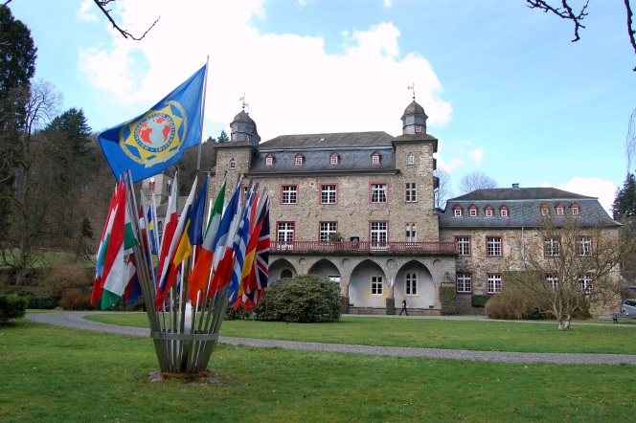

IBZ Gimborn offers over 30 seminars to IPA members and police staff each year. All seminars are organised at Gimborn castle in Germany. When looking for seminars in the programme for 2017, please note that the country flags represent the language/s each seminar is conducted in. If the seminar is bilingual, simultaneous translation between the two languages will be provided for your convenience.

*Photo by R Eidietis, Arthur Troop Scholar 2016*

From 27 November to 1December 2017, the seminar ‘Violence against Police Officers and Other Representatives of the State’ will examine if there is a new type of violence against police officers and state representatives. Do members of staff in the police forces, in public service or in schools have to serve as punching bags for those who feel disadvantaged and marginalised? Are extremists of all sorts happy to execute violence against state representatives? The seminar deals with current developments, presents attempts of explanation and looks at preventive and restrictive measures to fight against violence. It is supported by the Chair of the Professional Commission. To apply, please follow the link: [www.ibz-gimborn.de](http://www.ibz-gimborn.de)

The Diversion Center, headquartered in Marietta, GA, USA has recently begun to offer de-escalation training for police and correctional officers, and they offer an affordable, online option that I think many police departments around the world would be interested in investing in for their officers as a preemptive measure to protect their officers, citizens, and improve public relations, especially with the recent incidents of police brutality in the past few years. Please visit their website at <http://www.thediversioncenter.com/de-escalation-training-for-police-officers.html>

***May-Britt Rinaldo, Chair of the Professional Commission***

Nominations welcome for the IPA World Prize 2017

Each year, all IPA Sections worldwide are invited to forward nominations for the IPA World Prize to the International Executive Board (IEB) of the IPA.

This prestigious IPA award recognises and rewards contributions by individuals or organisations for special and lasting commitments through a project for the benefit of society on matters of Human Rights or the preservation of World Peace, and consists of a monetary award accompanied by a certificate.

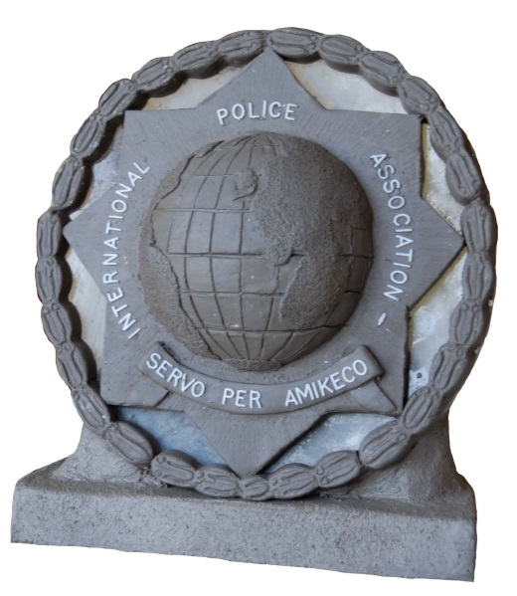The IPA World Prize is awarded during the annual IPA World Congress, and an official press release will be issued.

As a norm, one prize may be awarded per year.

In 2016, however, the nominations received by the IEB were of such high calibre that two prizes were handed out:

**Maria Appelblom**, member of IPA Sweden, received the IPA World Prize 2016 for her outstanding contribution to policing and other humanitarian projects over many years.

In addition, several **regions of IPA Greece** received the IPA World Prize 2016 in recognition for their exemplary efforts in providing humanitarian support and services to refugees and immigrants during the refugee crisis.

The nomination period for the IPA World Prize 2017 runs until **21 April 2017**, and we would therefore like to invite all IPA Sections to forward any nominations they might wish to submit as soon as possible to the IPA Secretary General, Georgios Katsaropoulos at [sg@ieb-ipa.org](mailto:sg@ieb-ipa.org) , with a copy to the IAC at [iac@ieb-ipa.org](mailto:iac@ieb-ipa.org) as soon as possible.

We look forward to hearing from you!

***Elke Schülpen-Roberts, Office Manager International Administration Centre***

**IPA HOUSES – YOURS TO DISCOVER!**

IPA House Velem, Velem (Vas County), Hungary

***The IPA House Velem is situated in the village of Velem, Vas County, Hungary. Velem dates back to 1279 and is situated in the Kőszeg Mountains, in a region known as Alpokalja (Lower Alps). It boasts a picturesque environment and healthy climate.***

Velem is a well-known tourist resort and holiday centre due to its favourable climate. The clean air is excellent for treating respiratory diseases. One of the sights of the village is the House of Crafts which showcases traditional folk arts.

Nearby are many towns with historical centres, such as Sopron and Kőszeg in Hungary, Lockenhaus and Lackenbach in Austria, as well as spas and thermal baths at Szombathely, Bük, Szentgotthárd and Sárvár in Hungary, Lutzmannsburg and Bad Tatzmannsdorf in Austria.

One of the best known annual events is the famous Chestnut Feast in October.

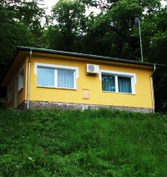Set in a large garden on the edge of a forest next to the Austrian border, the IPA House has 2 bedrooms and accommodates 4 people.

The house has running water, electricity, TV, waste removal, sewage, gas, bedding, towels and laundry facilities.

The property also benefits from gas central heating and air-conditioning

The living room provides a TV, a DVD player, and a TV broadcast UPC Direct satellite

**Contact Details & Bookings:**

* House Manager: Attila Ribes
* Address: H-9726 Velem, Fenyves u. 15
* Reservations: Attila RIBES
* Tel: +36 30 9164137
* Mobile: +36 30 9702242
* Email: [ribes@ipa-szombathely.hu](mailto:ribes@ipa-szombathely.hu)
* Website: <http://ipa-szombathely.hu/hu/kedvezmenyek/ipa-> hazak/ipa-haz-velem/

***Article compiled by H Vos (Vossie), SCC member***

IPA House Altes Schäferhaus, Büdingen, Germany

***The IPA House is situated in the grounds of a farm northwest of Büdingen and 40 kilometres north-east of Frankfurt/Main.***

Büdingen is a medium-sized town in the German state of Hesse on the eastern edge of the Rhine-Main area. It is located in a wooded area close to the Seemenbach at the transition of the Wetterau / Vogelsberg. The city is famous for its medieval old town with a castle, and has one of the best-preserved city centres in Europe. The surroundings are beautiful: woods, lakes and castles, as well as opportunities for skiing in winter.

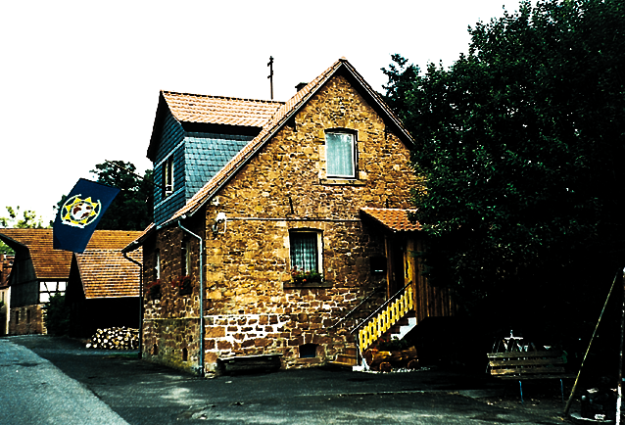Translated into English, 'The Old Shepherd House' has a large recreation room with a radio, television and a well-equipped kitchen.

On the first floor there is a small living room with a television and 2 divan beds, a double bedroom and a bedroom with bunk beds. In addition, the IPA House has a bathroom with a shower and toilet. A washing machine is situated in the cellar.

The House accommodates 6 people.

**Contact Details & Bookings:**

* Manager: Friedrich Schneider
* Address: Domäne Erbacher Hof, D-83654 Büdingen
* Tel: ++49 6042 950394
* Mobile: ++ 49 170 4151034
* email: schneider.ipa-buedingen@t-online.de
* Website : <http://www.ipa-deutschland.de>

***Compiled as per information received from Hubert Vitt, IPA Germany***

**LAST WORD**

The contents of what I write for the ‘Last Word’ tends to be determined by how much space is left at the end of the IPA Newsletter’s last page … and looking at it, this month I have got to keep it short ☺

I had a wonderful trip meeting an IPA member this month, but I guess this will have to wait until the April edition!

For now, I would like to encourage all IPA sections to send articles of your events to me at the IAC – it is a fantastic opportunity to promote the Association ☺

*Elke*

**CALENDAR OF EVENTS**

Please find below a list of IPA events for the next 12 months:

|  |  |  |
| --- | --- | --- |
| ***Section*** | ***Date*** | ***Event*** |
| Finland | 1-3 Mar 2017 | IEB Meeting, Äkäslompolo |
| Spain | 4 Mar 2017 | 10th Meeting of Police and Firefighter Collectors, Madrid |
| New Zealand | 11 Mar 2017 | Social Lawn Bowls Competition, Tauranga |
| Macau | 25 Mar 2017 | Launch of Asian Affairs Bureau, Macau |
| Croatia | 31 Mar-1 Apr 2017 | Conference ‘Security of historical cities’, Split |
| Austria | 20-23 Apr 2017 | XIX National Congress, Pörtschach |
| Poland | 29-30 Apr 2017 | 5th IPA Open Table Tennis Champ., Radom |
| Croatia | 29 Apr-13 May 2017 | IPA Dubrovnik Friendship Weeks 2017 |
| Croatia | 6 May 2017 | Precise Shooting Tournament, Stobreč |
| France | 12-15 May 2017 | Motorcycle Rally, Perpignan |
| Romania | 18-21 May 2017 | Meeting of Central and Eastern European Sections, Bucharest |
| Canada | 21-28 May 2017 | Cruise to Bermuda+ Tour of New York |
| Germany | 23-27 May 2017 | IEB Meeting, Gimborn |
| Spain | 25-28 May 2017 | XIV 7-a-side int’l football champ., Tarragona |
| Spain | 28 May-3 Jun 2017 | Barcelona Golf and Leisure Week |
| Estonia | 2-4 Jun 2017 | Nordic Baltic Meeting |
| Austria | 10-17 Jun 2017 | Hiking Week, Nassfeld |
| USA | 11-16 Jun 2017 | Young Police Officers’ Seminar, Green Bay |
| Czech Rep. | 11-17 Jun 2017 | Prague Friendship Week |
| Italy | 15-18 Jun 2017 | 7th IPA Motorcycle Rally, Dolomites |
| Spain | 15-18 Jun 2017 | II Champ Intern. Football 7, La Coruña |
| USA | 19-28 Jun 2017 | Pacific Northwest Tour |
| Romania | 21-26 Jun 2017 | 1st Int. Police Women’s Mtg ‘Danube Delta’ |
| Russia | 22-25 Jun 2017 | Northern European Forum, St. Petersburg |
| Germany | 23-25 Jun 2017 | 22nd FlyIn, Bonn |
| Estonia | 14-16 Jul 2017 | IPA Estonian Summer Days |
| South Africa | 29 Jul-13 Aug 2017 | International Youth Gathering |
| Germany | 11-13 Aug 2017 | 1st Int. Motorcycle Gathering, Hamburg |
| Spain | 7-10 Sep 2017 | IX Champ. Int. ‘Ibérico de Fútbol, La Coruña |
| Bulgaria | 19-24 Sep 2017  24 Sep-1 Oct 2017 | 62nd IPA World Congress, Albena  Friendship Week |
| USA | 1-6 Oct 2017  6-10 Oct 2017 | NDC Meeting, Charleston  Friendship Tour Charleston and Savannah |
| Netherlands | 9-13 Oct 2017 | 35th WPIST, Eibergen, Groenlo and Lichtenvoorde |

**FORTHCOMING GIMBORN SEMINARS**

Please see below a 4-month summary of seminars with vacancies, offered by our international education centre IBZ Gimborn in Germany.

If you are interested in taking part in any of these seminars, please follow the link:

[www.ibz-gimborn.de](http://www.ibz-gimborn.de)

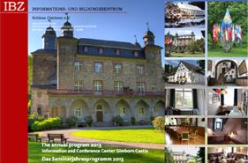

|  |  |  |
| --- | --- | --- |
| ***Date*** | ***Seminar*** | ***Language*** |
| 17-19 Mar 2017 | Qualifizierte Vernehmungen im Bereich der Schwer- und Bandenkriminalität | G |
| 20-24 Mar 2017 | Aktiv in den Ruhestand | G |
| 27-29 Mar 2017 | Die Macht der Bilder oder Bilder an die Macht | G |
| 03-05 Apr 2017 | Führung in Aussicht / den Rollenwechsel meistern | G |
| 18-22 Apr 2017 | ASP Instructor Course | E |
| 24-28 Apr 2017 | La contrefaçon – Une menace sous-estimée ? | F |
| 08-12 May 2017 | Social Media Management für Polizei, Justiz und Öffentliche Verwaltung | G |
| 08-10 May 2017 | Europa in der Krise – Herausforderungen in der Flüchtlingskrise // Europa in crisis – uitdagingen in de vluchetlingencrisis | G and D |
| 22-24 May 2017 | Zeitalter der Populisten | G |
| 29 May-02 Jun 2017 | Cybercrime – Kampf gegen die Bedrohung aus dem Cypercrime | G |
| 23-25 Jun 2017 | Fortbildung 2017 Funktionäre IPA Deutsche Sektion | G |
| 26-30 Jun 2017 | Interkulturell kompetent in der Zuwanderungsgesellschaft | G |